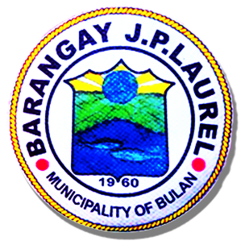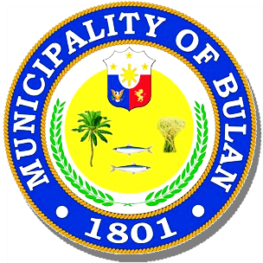Republic of the Philippines

**MUNICIPALITY OF BULAN**

Sorsogon  SORSOGON

**BARANGAY J.P. LAUREL**

OFFICE OF THE PUNONG BARANGAY

**Certificate of Indigency**

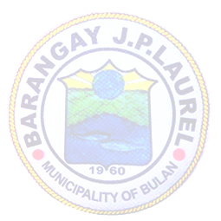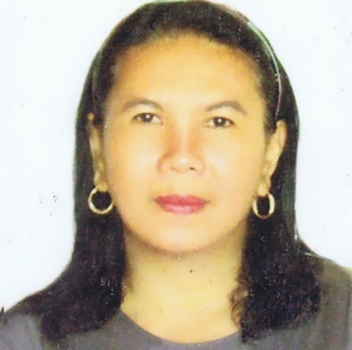

**BARANGAY OFFICIALS**

**NORIE G. CAÑEZAL**

**Punong Barangay**

**BARANGAY KAGAWAD**

**MARY JANE G. ESQUILLO**

**JUNIE G. BREZUELA**

**LERMA O. GRANADIL**

**RENAN G. GOLLOSO**

**VENER P. BERANIA**

**FLORENCE M. SUS**

**JOSEPH H. ALMOGUERA**

**SK CHAIRMAN**

**RONNEL G. GUETA**

**JONNA B. AGNE**

Barangay Secretary

**AGNES R. JUAB**

Barangay Treasurer

**To Whom It May Concern:**

ANGELICA H. ESPINAR

This is to certify that ______________________________, of legal age and a resident of Barangay J.P. Laurel, Bulan, Sorsogon, He/She belongs to an indigent family whose parents means of livelihood is derived from farming.

Per decleration of Mrs. ANGELITA H. ESPINAR before this office. Their monthly income is Thirty Thousand pesos (30,000.00) only.

In need for;

Purpose : School Requirement

Issued upon request of the subject this 21st day of July 2022 at Barangay J.P.Laurel,Bulan,Sorsogon

Approved:

***NORIE G. CAÑEZAL***

Punong Barangay

***Note!:*** *Not valid without seal*

//.om~.20